**VACCINATION REQUIREMENTS**  
Proof of FULL Vaccination (Which Includes Booster)

A negative COVID-19 test (antigen rapid test preferred, PCR if that's all that's available) within 72 hours of the meeting start date.

**No Exceptions**

Registration is required so that our vendor, 42Chat, can send a text message to your phone instructing you to upload the required documentation. By uploading your materials BEFORE you leave home, there will be minimal hassle once you are here in DC.  [**In full disclosure, as an establishment in Washington, DC, the Willard Hotel is subject to the DC Mayor's Order 2021-148 which requires vaccination to enter certain establishments as of January 15, 2022.**](https://nam02.safelinks.protection.outlook.com/?url=https%3A%2F%2Fcoronavirus.dc.gov%2Fsites%2Fdefault%2Ffiles%2Fdc%2Fsites%2Fcoronavirus%2Fpage_content%2Fattachments%2F2021-148%2520Vaccination%2520Requirement%2520for%2520Entrance%2520into%2520Certain%2520Indoor%2520Establishments%2520and%2520Facilities.pdf&data=04%7C01%7Cdampierd%40marshall.edu%7C24723034a5c1465df43d08d9d5594b40%7C239ab2783bba4c78b41d8508a541e025%7C0%7C0%7C637775402519489957%7CUnknown%7CTWFpbGZsb3d8eyJWIjoiMC4wLjAwMDAiLCJQIjoiV2luMzIiLCJBTiI6Ik1haWwiLCJXVCI6Mn0%3D%7C1000&sdata=WuC%2BLX2EJK96KESavP4RSieodwVLUfYstB9KdU7QAn4%3D&reserved=0)Listed facilities (see page 2 of the Order) include hotel common areas and meeting facilities.  Therefore, you will need to carry proof-of-vaccination to enter the hotel.

* In order to register for the meeting, we also need your name, email address, and cell phone number. [Please click here](https://nam02.safelinks.protection.outlook.com/?url=https%3A%2F%2Ffs30.formsite.com%2Fcpost%2Febwo5lqya6%2Findex.html&data=04%7C01%7Cdampierd%40marshall.edu%7C24723034a5c1465df43d08d9d5594b40%7C239ab2783bba4c78b41d8508a541e025%7C0%7C0%7C637775402519489957%7CUnknown%7CTWFpbGZsb3d8eyJWIjoiMC4wLjAwMDAiLCJQIjoiV2luMzIiLCJBTiI6Ik1haWwiLCJXVCI6Mn0%3D%7C1000&sdata=L1%2BsBPF1Ugm18TFOuI67aRU8JZX%2Bqoe67%2FFAr9Zn894%3D&reserved=0) to enter your information.
* **Attendees who have provided mobile numbers at registration will receive a text message with a link to upload documents.**
* **If you do not receive a text message, you can scan the QR code below to upload your document.**

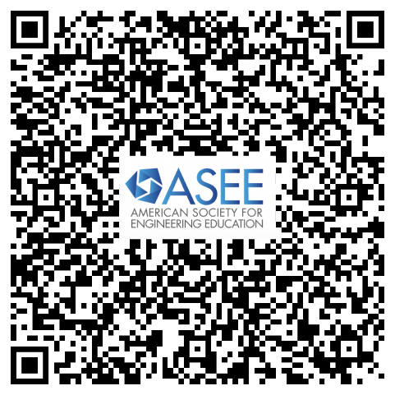

**Each participant must upload their own document through their own mobile device.**

Your cell phone number WILL NOT be retained after this registration and will not be provided to any entity beyond 42Chat solely for the purpose of registration for this event (this means if you plan to attend other ASEE events, you may be asked to again provide the same information).

**Note:**

* ALL attendees are required to provide proof of **FULL vaccination**(which includes booster).
* Attendees who do not register online will be required to provide proof of **FULL vaccination** (which includes booster) when they arrive to register onsite.
* For ALL attendees, a **negative COVID-19 test** (antigen rapid test preferred, PCR if that's all that's available) within 72 hours of the meeting start date.
* ASEE hopes to have antigen tests available onsite if (a) you are not able to obtain one beforehand, or (b) you want a second test after going through airports, etc.
* If you only take the onsite test and are positive, you will be excluded from the meeting.
* There will be No Exceptions to these vaccination and testing requirements.