Author's Kit

Thank you for participating in the 2023 ASEE Annual Conference and Exposition in Baltimore Maryland.

This kit is a guide to help you submit and manage all abstracts and papers. Authors are responsible for following the procedures and meeting all deadlines and requirements in the paper submission process. ASEE is not responsible for papers that are withdrawn because they were incomplete or deadlines were missed.

If you have any questions, please contact the ASEE Conferences Staff at Conferences@asee.org or 202-350-5720.

Regards,

Patti Greenawalt
Managing Director

2023 ASEE Annual Conference Timeline
All deadlines occur at Midnight, Eastern Standard Time on the days listed

Monday, October 3, 2022
- Abstract Submission Open
- Abstract Reviewer Assignment Open

Monday, October 31, 2022
- Author Deadline: Abstract Submission Closed

Monday, November 7, 2022
- Session Requests Open
- Workshop Application Open
- Topical Plenary Application Open

Monday, November 21, 2022
- Abstract Accept or Reject Notification to Author Deadline

Monday, December 5, 2022
- Session Request Deadline
- Workshop Request Deadline
- Topical Plenary Application Deadline

Monday, January 9, 2023
- PROGRAM CHAIRS: Session request approvals by PICs

Tuesday, January 31, 2023
- AUTHOR DEADLINE: Draft Paper Submission Deadline

Wednesday, February 1, 2023
- PROGRAM CHAIRS: Ticket Information Deadline for Session

Monday, February 6, 2023
- ALL ATTENDEES: Housing and Registration Open

Tuesday, February 14, 2023
- REVIEWER DEADLINE: Anonymous Draft Paper Reviews to Program Chair

Tuesday, February 28, 2023
- PROGRAM CHAIR DEADLINE: Draft Decision Deadline

Tuesday, March 21, 2023
- AUTHORS: Anonymous Paper with applicable requested revisions: upload deadline
Saturday, April 1, 2023
- PROGRAM CHAIRS:
  - Final paper transfer deadline

Saturday, April 15, 2023
- PROGRAM CHAIR DEADLINE: Accept/Reject Revised Paper deadline

Sunday, April 30, 2023
- AUTHOR DEADLINE:
  - Author Registration Deadline
  - Upload final paper – all Anonymous indicators removed
  - Confirm all co-authors
  - Update all author bios, if applicable
  - Corresponding author indicates who is “presenting”

NO CHANGES of any kind for any papers can be accepted after this date

Sunday, May 22, 2023
- PROGRAM CHAIR DEADLINE:
  - o Deadline for details for all sessions
  - All finalized papers assigned to sessions
o Session and workshop cancellation deadline
    - Sessions not cancelled by this date are final
o F&B and AV request deadline
o “Session DONE" Deadline

June, 2023
- DEADLINE FOR ALL
  - Attend Annual Conference
  - Complete Surveys

July, 2023
- 2024 Division Offer List due

August, 2023
- 2024 Call for Papers are due

Author Responsibilities

Each Author who submits an abstract and paper should:

- Read this kit and follow all of the instructions (this is extremely important)
- Submit their abstract as a TEXT ONLY and their draft as a PDF ONLY
- Acknowledge the Plagiarism Policy
- Acknowledge the Copyright Transfer
- Check that all information; from the paper title to the spelling of co-authors’ name/s, is correct
- Indicate who is presenting the paper
- Pay the registration fee
- Assign someone else to manage your paper or pay your fees, if you are unavailable to do so yourself
- Contact ASEE Conferences Staff at conferences@asee.org or 202.350.5720 with any questions or problems

Potential problems

Be advised, your paper will not be published if you:

- Fail to submit a final copy of the paper before the deadline
- Fail to have at least one author registered for the conference by the deadline

Other authors have had papers published with unfortunate mistakes. Please don’t let these happen to you:

- Failure to add co-authors and check the spelling of their names before marking your paper as finalized
- Failure to proofread your biography before submitting the final paper
- Failure to check the uploaded version of the final paper for formatting and other errors

BE ADVISED!
- ASEE will withdraw papers that do not have at least one author registered by the deadline.
- REMINDER: If that one author cancels their registration, the paper will subsequently be withdrawn.

Conditions:

- Peer review occurs for both abstracts and papers. Abstract acceptance does not guarantee acceptance of the paper. All divisions have a Publish-to-Present requirement and final papers must be written and accepted for the work to be presented at the 2023 ASEE Annual Conference.

- In addition, the Program Chair has the sole discretion to assign the accepted paper to a technical session (for oral presentation) or a poster session.

- Submission of abstracts and final papers will be via the NeMo system and in accordance with ASEE published deadlines.

- Plagiarism Policy:
  - You will be required to acknowledge and accept the plagiarism policy before you can submit your abstract. The plagiarism policy can also be found in Appendix E

- Copyright Acknowledgements
  - You will be required to acknowledge the copyright policy before you submit the abstract. The copyright policy can be found in the Appendix G

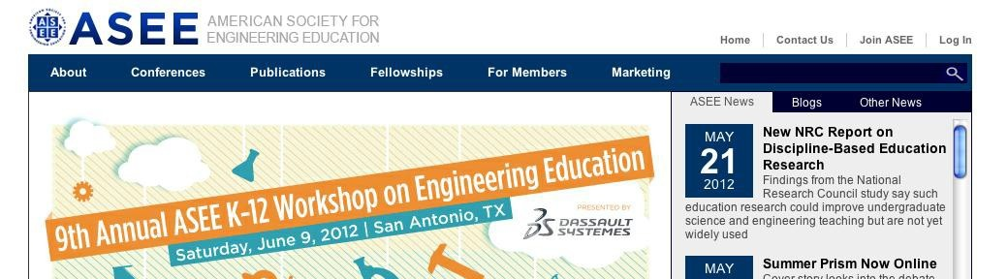
Logging into the System

- From the home page (http://www.asee.org), click on “log in” in the upper right hand corner.

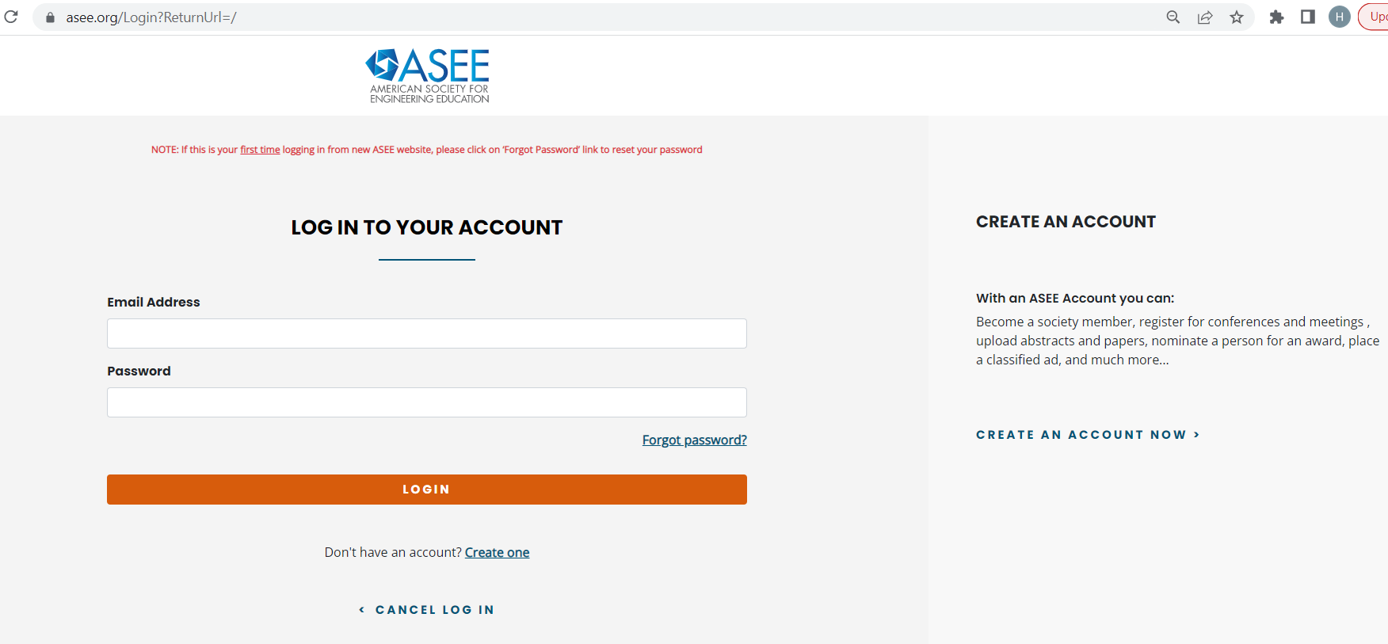

MEMBERS

- If you are an ASEE member, do not try to register for a new account, please contact us at conferenes@asee.org for assistance if you are unable to activate your account.
- When you return on subsequent visits, log in with your email address and the password you chose when activating or registering.
NON-MEMBERS
- If you are a non-ASEE member or a new user, you must create an account with us.

WELCOME PAGE
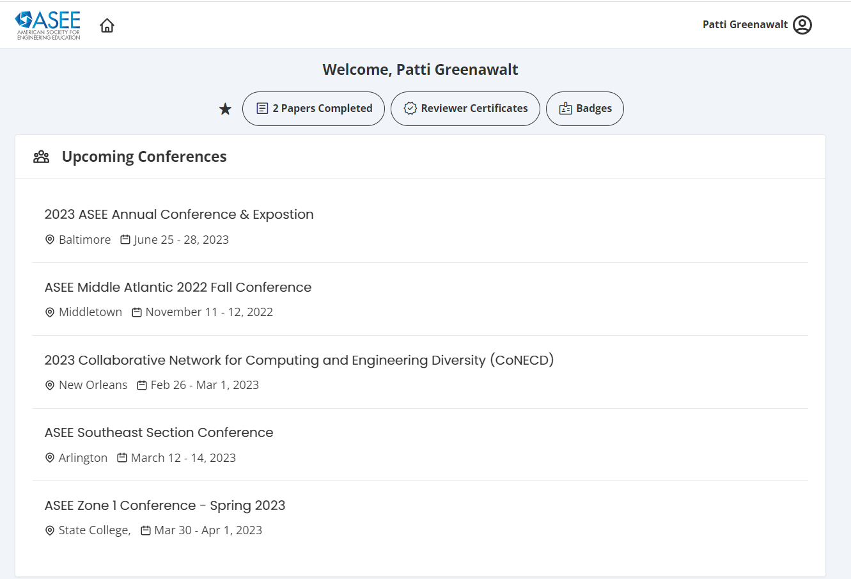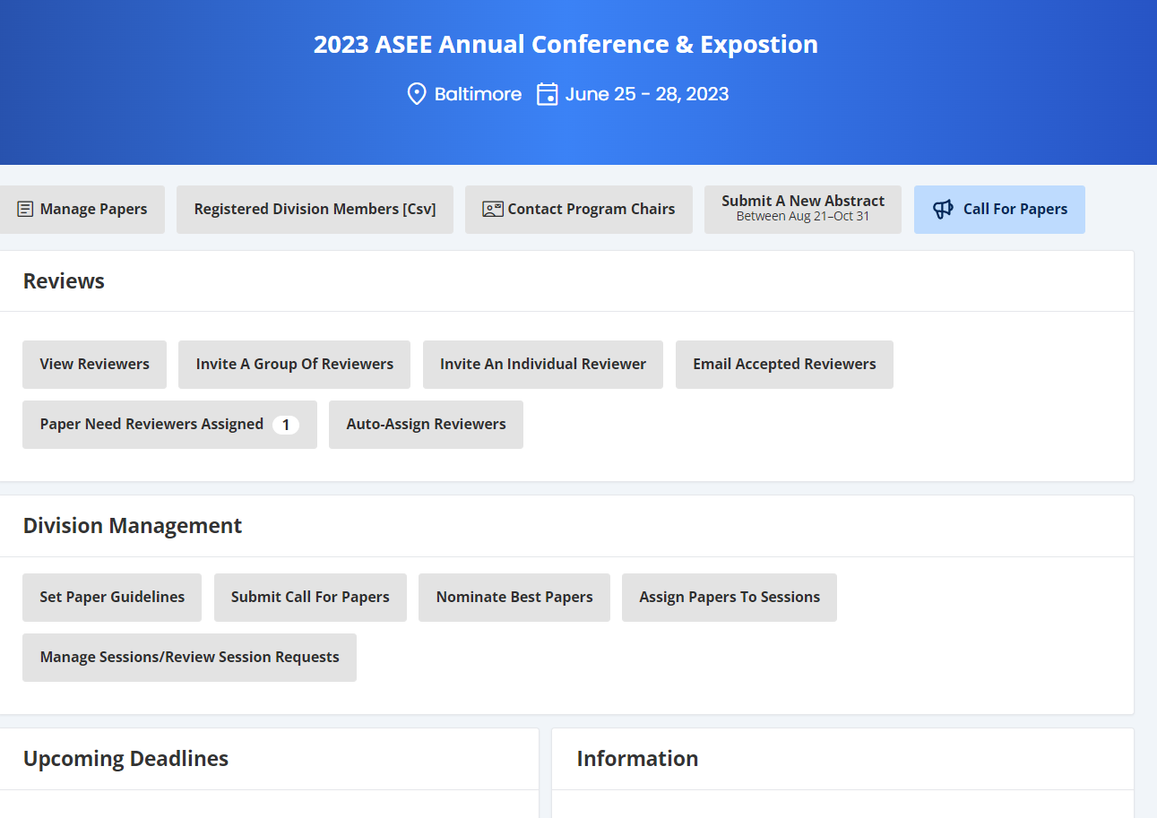
- You will be taken to your Welcome Page where you will find “Upcoming Conferences” click on that and then click on 2023 ASEE Annual Conference & Exposition.
- You can also edit your personal information, as well as manage conference papers and sessions.

Paper procedures

If you have any questions regarding your paper reviews, revisions, accept/reject decision or paper assignments to timeslots; you must contact your Program Chair directly.

Program chairs contact information is located on your Manage Papers page.

As mandated by the ASEE Board of Directors, all divisions are publish to present. For a paper to be presented at the Annual Conference or included in the Conference Proceedings, it must pass through the entire review process and be accepted as shown below.

Abstract Author submits abstract
- Program Chair assigns reviewers
- There is a minimum of one (1) review required for an abstract
- Reviewers read, rank, and comment on abstract
- Program Chair accepts or rejects abstract

Draft Author submits draft
- Program Chair assigns reviewers
- Three (3) reviews are required for a draft paper
- Reviewers read, rank, and comment on paper
- Program Chair receives reviewers requested revisions, and sends them to Author if applicable
- Program Chair accepts/rejects papers and revised papers

Register
- at least one Author per paper pays registration fee

Ready to Publish
  - Author submits final paper
  - All anonymous indicators removed

Submit abstract (October 3 – October 31) See Appendix B for guidelines
To submit an abstract, enter the text in the box indicated and enter the required information about yourself and the abstract. You can select exactly how your name and institutional affiliation will be printed in the conference proceedings.

You can also indicate if this paper is a “Work in Progress”.

BE ADVISED!
- Some divisions do not accept “Works in Progress” so please be sure to read the Call for Papers closely for this information.

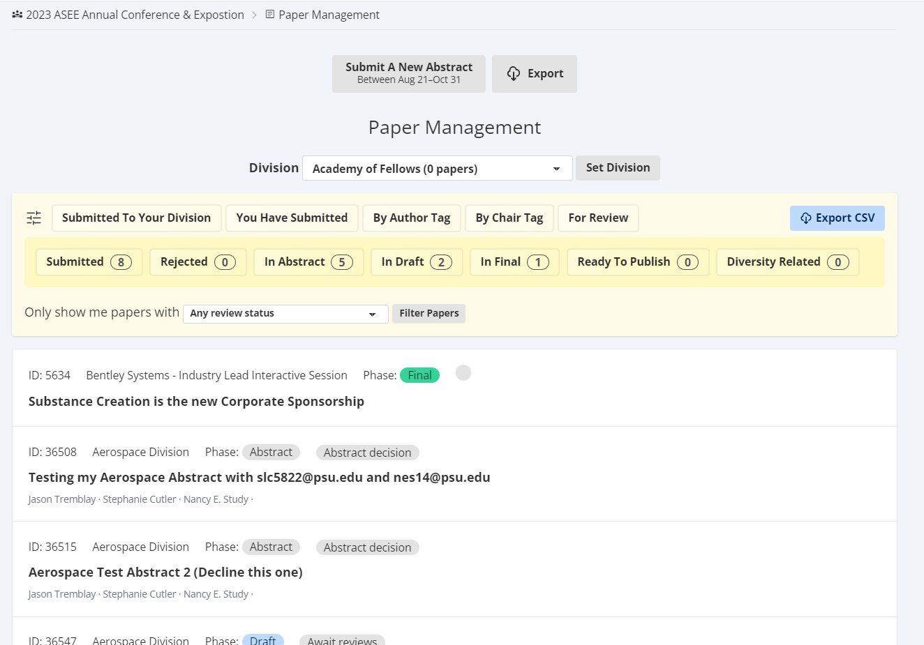

Please be sure that an Author bio is included for each submission
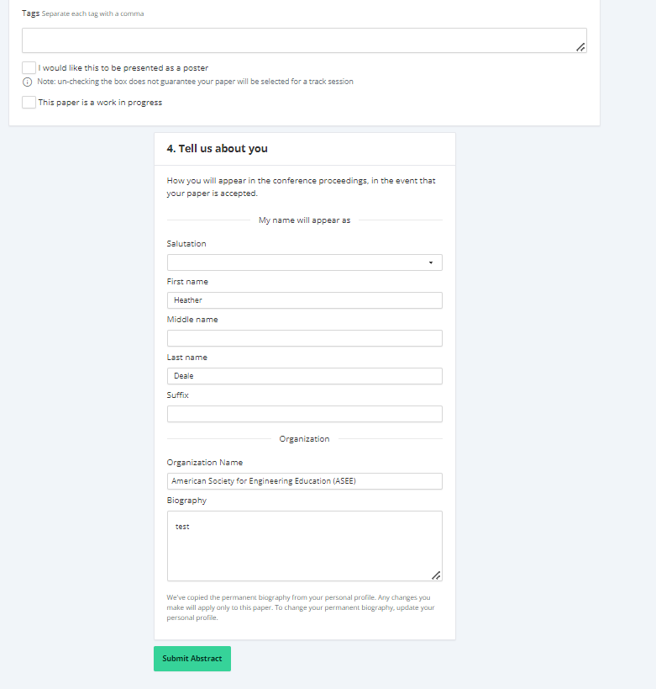

From the paper management screen, you can see all of the papers you have submitted or have been assigned to review.

After you submit the abstract, it appears on your paper management screen with the status message Can edit abstract.

BE ADVISED!
- Reviewers are assigned as soon as abstracts are submitted. You will NOT be able to make any edits to abstracts once it’s submitted.
  - Therefore, please only submit the abstract text when it is ready to be reviewed.
- Once reviews are in progress, the abstract’s status changes to “Waiting”
- If you need to revise your abstract after it’s assigned to a reviewer, you must contact your program chair for assistance. It is at your chairs’ discretion whether they will update the abstract for you or not.

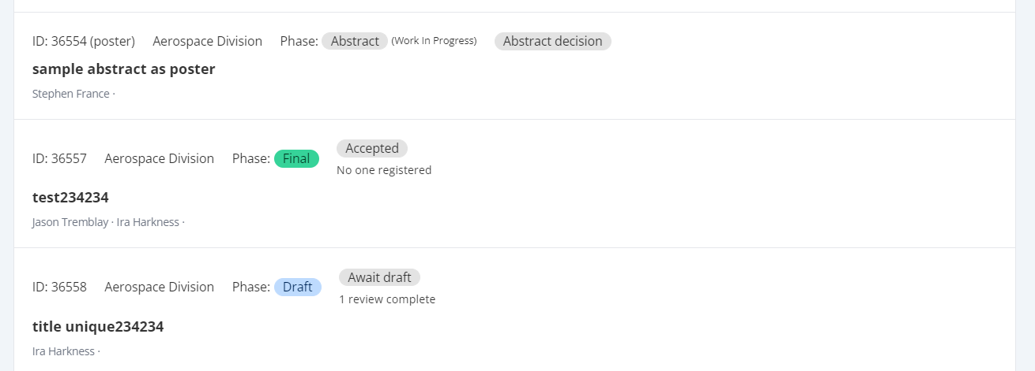

After the reviews are finished, the program chair decides to accept or reject your abstract.

If your abstract is accepted, the status changes to Upload draft.

Draft Paper Submission Process (Draft upload deadline, January 31, 2023)

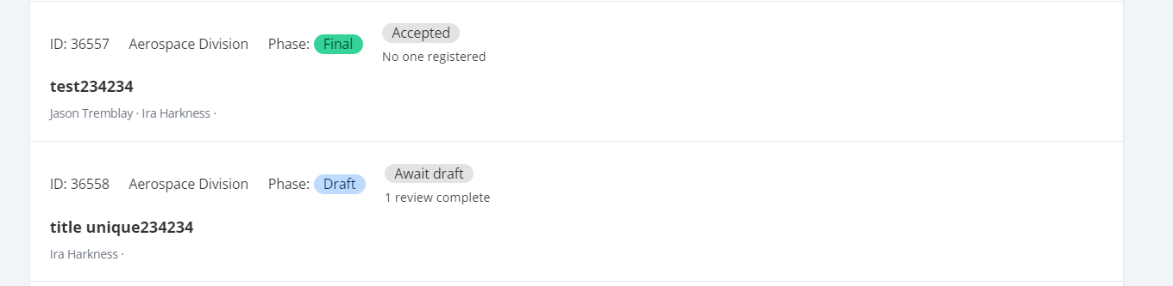

- The paper’s details page provides a link to read comments from reviews as forwarded by the program chair.
- When the draft version is completed, Choose file (as a PDF only) and Upload draft to submit it. Make sure that the PDF file you upload doesn’t include your name or initials.
- You can upload your draft paper as often as needed until the program chair assigns the draft paper to be reviewed.
- Again, the paper’s status changes to Waiting until the reviews are complete and the program chair has made his or her decision.

BE ADVISED!
- Reviewers are assigned as soon as drafts are submitted.
  - Therefore, do not submit your draft until it is ready to be reviewed
- Once reviews are in progress, the paper’s status changes to Waiting”
- If you need to revise your draft after it’s assigned to a reviewer, you must contact your program chair for assistance. It is at your chairs’ discretion whether they agree to upload a new version of the draft for you or not.

If the paper is accepted as is, its status changes to upload final.

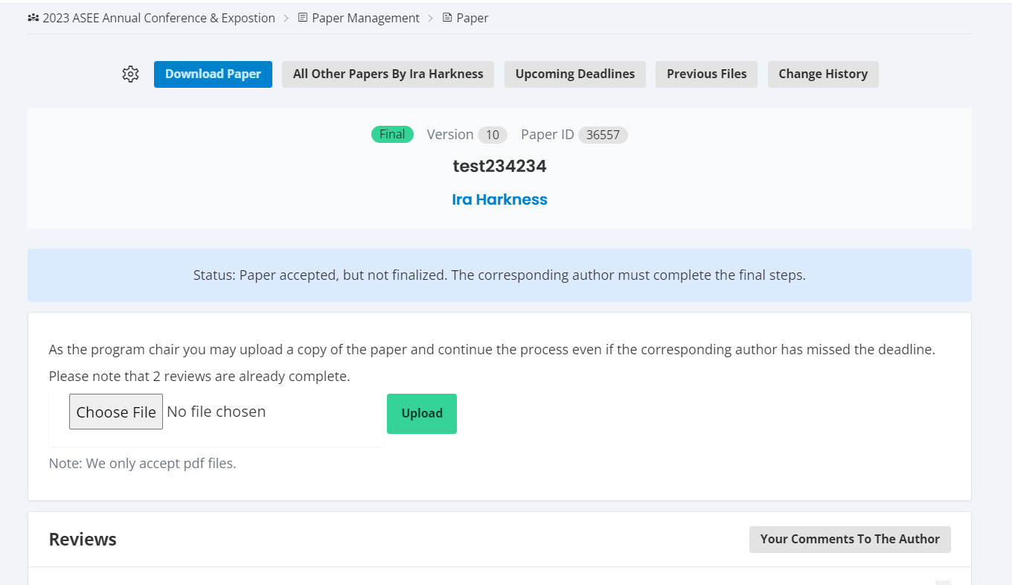

If Revisions have been requested, they need to be submitted (by Mar 21, 2023).

- As with abstracts, you can view comments from the reviewers on the paper’s details page.
- If the paper is accepted with revisions, its status changes to Revise.
- When the requested revisions are ready, select the PDF file and Upload.
- When requested revisions for the paper are uploaded, its status changes to Waiting until it is accepted or rejected by the program chair.

BE ADVISED!
- If you have been requested to make revisions, the system automatically assigns the revision to a reviewer as soon as it is uploaded. Therefore, you will only be able to upload ONE VERSION of a revision.
- If you need to upload a different version of the revision, you must contact your program chair for assistance. It is at your chairs’ discretion whether they agree to upload a new version for you or not.
- ASEE HQ Staff cannot upload any attachments for you. That is done only by the Chair.

- Edits cannot be made during the “waiting” stage.

Paper Acceptance:
Once the final paper is accepted by the chair, you will need to complete the following by April 30, 2023.

- One author must register and pay for the conference.

BE ADVISED!

- The presenting author must be a registered participant in order to present their paper at the annual conference.

Finalize Paper:
By April 30, 2023 you will need to finalize your paper by completing the following requirements:
- Upload the final version of your paper with the anonymous components reinstated, such as name, institution, etc.
- Make sure all co-authors have been invited to a paper, accepted the invitation, and have completed their information.
  - See instructions for adding co-authors.
  - Check for correct spelling of co-authors names.
- Submit final version of all author bio/s.
- Review paper prior to final submission for formatting errors or concerns.

BE ADVISED!
- Papers cannot be assigned to a session until the paper is finalized

Session Assignments:
- Program chairs are scheduled to have all papers assigned to sessions by May 22, 2023. You can go to www.asee.org/osl to confirm session slot assignment after this date.
- Papers are assigned by preferred order by the Program Chair.
- If you have any issues with any session assignments, you must contact the program chair directly.
  - ASEE HQ staff cannot re-assign papers. That is only done by the Program Chair.

On-site Presenter Guidelines

2023 ASEE Annual Conference On-site Presenter Instructions
- Presenter
You have been assigned to present your paper at the ASEE Annual Conference. If you cannot present or feel you got the request in error, contact the corresponding author directly.
- Registration
Be advised, that you must BE REGISTERED to present your paper at the ASEE Annual Conference.
- Technical Issues
If you’re having technical difficulty accessing the paper through the website, contact ASEE Conferences at conferences@asee.org or 202-350-3720
- Session Issues
If you have any questions regarding the session content, please contact the program chair directly. Program Chair contact information is in the Annual Conference section of Upcoming Conferences on your home page.
To access your paper
- Log into www.asee.org
- Click on Upcoming Conferences
- Click on 2023 ASEE Annual Conference
- Click on Manage Papers
Presenter Responsibilities
- Each session is 90 minutes long
- The presentations are typically distributed evenly among the 90 minutes, including Q&A
- The program chair has determined the timeslot and order that papers will be presented. If you have any issues with scheduling, contact the program chair directly.
  - ASEE has no control over paper or session scheduling. This is only done by the chairs
- There’s a moderator assigned to each technical session, they are responsible for keeping the session on schedule. Please take your direction from them on-site.
On-site Presentation Guidelines
- PowerPoint is the preferred presentation method
- A PowerPoint template is provided for your convenience. It is located in the Author section of the ASEE Annual Conference Website
  - You are not required to use this template
- A screen, LCD projector, podium and mic are provided in the session rooms. Computers are NOT PROVIDED in the rooms, therefore please bring your laptop as well as your presentation on a flash drive.
- VGA and HDMI connections are available for the projectors ONLY if you require a different type of connection, please BRING IT WITH YOU
- Internet is NOT provided in the meeting rooms and would have needed to be ordered in advance to be available.
  - We suggest presenters use their cell phone as a hot spot for their presentation if available and/or necessary
  - If you require internet and do not want to use your phone as a hotspot, please contact ASEE Conferences Staff at conferences@asee.org

ASEE 2023 Poster Presentation Guidelines

The information below pertains to the NSF Grantees, and Division Poster Sessions.

NEW THIS YEAR! Poster Hanging/Removal Times

Posters can be installed in the exhibit hall as early as Sunday Afternoon, and will remain throughout the duration of the conference. Poster Boards will be labeled with specific numbers and paper titles. Presentation times are as follows:

Student Showcase
Sunday, June 25, 2023
5:00 PM – 7:00 PM

ASEE Division Poster Session
Tuesday, June 27, 2023
9:15 AM – 11:45 AM

NSF Grantees Poster Session
Wednesday, June 28, 2023
9:15 AM – 11:45 AM

Poster Board Dimensions
- The dimensions of the poster boards are 8’ wide x 4’ high.

- These poster boards are double sided (one roster per side) and each side will be used for poster presentations and will be numbered

You may use up to 8’x4’ section of each side
- Pins to place the presentations on the boards will be available for your convenience, but it's always good to be prepared as the pins sometimes get moved around.
- Please plan to be in the exhibit hall prior to your group’s presentation time.
- When entering the exhibit hall, please look for your number on the poster board.

Poster Board Assignments
- You will be notified of your poster assignment by ASEE Conferences Staff sometime in May
- Posters will be organized by division and then by Paper Title
- If you have more than 1 poster in two different divisions, your poster assignments WILL NOT BE TOGETHER!
- You will need to make arrangements with someone else to present your other poster, or pin a business card to your poster so the attendees can contact you if they would like.

Purpose of a Poster Presentation
- Acquaint conference participants with the fundamentals of your program, project or study quickly and easily.
- Use text, graphs, tables, charts, and pictures to present only highlights.
- Catch your viewer’s attention.
- Make the viewer want to learn more about your program, project or study.

Designing an Effective Poster
- Include the abstract title and all authors at the top. You may include the authors' names, e-mails, and address information in case the viewer is interested in contacting you for more information.
- Your poster should fit on a board that is 8’w x 4’h (242 cm. x 121 cm.). The exact size is up to you, but it’s recommended to be no bigger than 7.5’w x 3.5’h
- Keep any text brief.
- Do not use all capital letters.
- Use graphics (charts, tables, pictures) that can be understood in one minute or less.
- Assume the viewer will be reading your poster from approximately 3 feet away.
- Describe all parts of the project/study, including why the outcome did or did not work as expected.
  - Background
  - Objectives
  - Research Design/Program Description
  - Results/Evaluation
  - Conclusion(s)
  - Future Plans
- The viewer should gain new knowledge or insight by visiting your poster.
- Consider providing a handout summarizing your research and include your contact information or be sure to have your business cards available for those who request your contact information.

Poster Session Etiquette
- Posters must be hung up at least 30 minutes before the poster session starts and taken down within 30 minutes after the session ends. Please do not use this time to preview other posters. Once you have placed your poster please exit the poster hall until it opens.
- Stand by your poster for the duration of the poster session.
- Chairs are provided only for those with special accommodation needs.
- Tables are not provided

Reminder
- Push pins will be available.
- Poster numbers will be displayed on the boards, you do not have to print the number on your poster.

APPENDIX A

Adding co-authors

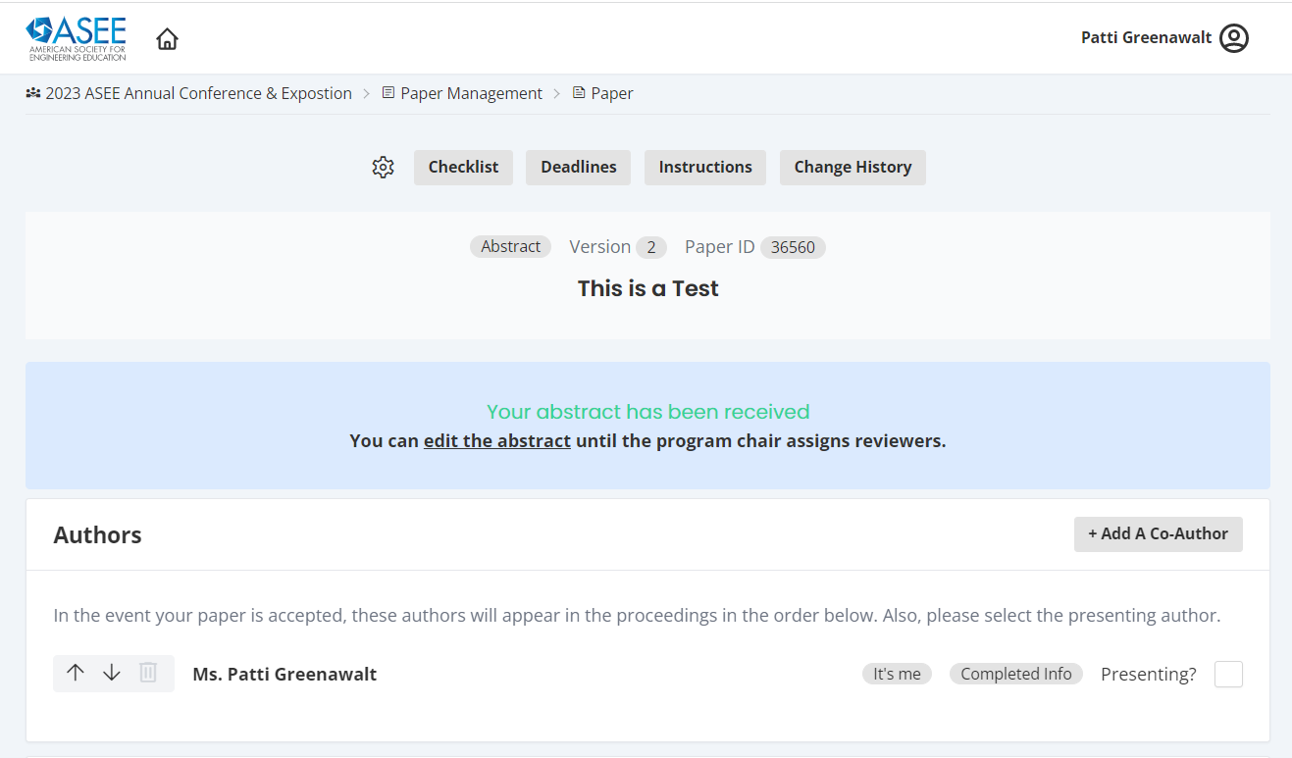

- Every paper has one main or corresponding author, who conducts all of the main business previously discussed.
- If your paper has co-authors, corresponding authors will be required to send invitations.
- Co-Authors can accept the invitations by clicking on the link in the email notification.
- FCo-authors can also view the paper’s status.

BE ADVISED!
- Only corresponding authors can upload attachments and only corresponding authors can assign that designation to a different co-author.

In the Authors section, add a co-author by searching for a name or institution.
- If the co-author is an ASEE member or has previously participated in the conference, he or she will appear in the search results.

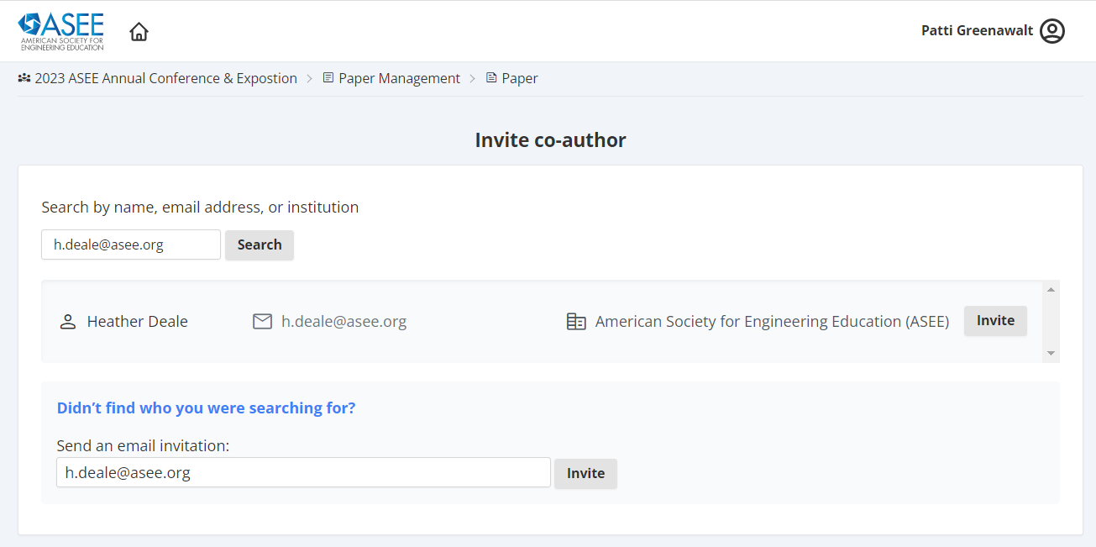

- If you can’t find a co-author by name, try their email address. If we don’t have an account for that address, you can invite them by email.
- The co-author can then create an account and decide how their name, institution, and biography will appear.
- Once you have added co-authors, you can place them in order. The ordering you set will be the order they appear in the program guide and on the paper’s cover page.
- Also the default is for the corresponding author to be the one presenting the paper. If that is not correct, please select the presenting author from the list of co-authors. This can be done using the radio button next to the co-author.

Appendix B

Abstract Format Guidelines

Be ADVISED: Abstracts are submitted via Text box only . Please note the following:

Title:
- Title: The title must be included
- Author and Affiliation: Submissions are done in a double anonymous . No author or affiliation information is to be included on any abstracts.
- Footers: Do not include any in your abstract.

Body of the Abstract (beginning under title information)
- Length: Abstracts should generally be between 250 - 500 words.

Biographical Information
Biographical information is to be saved in NeMo on the Author/Co-Author page. It will be automatically added to your paper at the end of the process.

Other
Do not include session numbers in any part of the document, unless specifically requested to do so by a Call for Papers.

Additional Guidelines and Suggestions:

• As appropriate, include the pedagogical theory or approach being used;

• Indicate the form that your outcome(s) will take as appropriate;

• As applicable, methods of assessment should be made clear.

Appendix C

DRAFT PAPER FORMAT GUIDELINES

Title Page (top part of first page only)
- Title of Paper: The title must be centered with at least a one and one-half inch margin on the left and right.
- Font: Times New Roman typeface is required, bold faced, 14 point.
- Author and Affiliation: Submissions are done in a double anonymous . No author or affiliation information is to be included on any abstracts or draft papers.
- Footers: These will be automatically added to your papers. Please leave them blank.

Body of the Paper (beginning under the title information on the first page and continuing with all subsequent pages)
- First Page: The paper will be in a one-column format with left justification.
There must be a one inch margin on the left, right, and bottom.
Font: Times New Roman typeface is required, 12 point, skipping one line between paragraphs.
- Second and All Subsequent Pages: There must be a 1 inch margin all around (top, bottom, right, left) in one column format, left justification, skipping one line between paragraphs.
Font: Times New Roman typeface is required, 12 point, using only standard symbols and abbreviations in text and illustrations.
- Abstracts: Abstracts are not required, but can be included between the title and the body of the paper, but not on a separate page.
- Headings: Headings are not required but can be included. If used, headings must be left justified, lowercase, with the same font and size as the body of the paper. There must be only one blank line between the heading and the paragraph.
- Page Numbering: Do not number the pages.
- Length: There is no set limit for the number of pages a paper can or must be. (Please note, even though there is no current limit for the number of pages, reviewers as well as readers of your work appreciate conciseness.)

References:
The preferred reference style is IEEE - see appendix F

Biographical Information
Biographical information is to be saved in NeMo on the Author/Co-Author page. It will be automatically added to your paper.

Other
Do not include session numbers in any part of the document.

Appendix D

Final PAPER FORMAT GUIDELINES

Title Page (top part of first page only)
- Title of Paper: The title must be centered with at least a one and one-half inch margin on the left and right.
- Font: Times New Roman typeface is required, bold faced, 14 point.
- Author and Affiliation: No author information is to be included since that is saved in NeMo. Any placeholders used to disguise affiliation in the draft paper (such as “University of _____”) should be replaced with the affiliation information
- Footers: These will be automatically added to your papers. Please leave them blank.

Body of the Paper (beginning under the title information on the first page and continuing with all subsequent pages)
- First Page: The paper will be in a one-column format with left justification.
There must be a one inch margin on the left, right, and bottom.
Font: Times New Roman typeface is required, 12 point, skipping one line between paragraphs.
- Second and All Subsequent Pages: There must be a one inch margin all around (top, bottom, right, left) in one column format, left justification, skipping one line between paragraphs.
Font: Times New Roman typeface is required, 12 point, using only standard symbols and abbreviations in text and illustrations.
- Abstracts: Abstracts are not required, but can be included between the title and the body of the paper, but not on a separate page.
- Headings: Headings are not required but can be included. If used, headings must be left justified, lowercase, with the same font and size as the body of the paper. There must be only one space between the heading and the paragraph.
- Page Numbering: Do not number the pages.
- Length: There is no set limit for the number of pages a paper can or must be. (Please note, even though there is no current limit for the number of pages, reviewers as well as readers of your work appreciate conciseness.)
- Pages can be landscape to accommodate graphics if necessary, all other requirements above still apply.

Biographical Information
Biographical information is to be saved in NeMo on the Author/Co-Author page. It will be automatically added to your paper.

References:
The preferred reference style is IEEE - see appendix F

Other
Do not include session numbers in any part of the document.

APPENDEX E

ASEE Official Plagiarism Policy

Policy on Plagiarism and Duplicate Publication
American Society for Engineering Education

May 31, 2013; Revised October 2, 2014

Preamble

The American Society for Engineering Education serves the engineering and technology communities by offering professional conferences, networking opportunities, and support of research in the various fields of engineering and technology related to education. Research is disseminated to the wider community via the organization’s professional publications. ASEE subscribes to the highest standards of ethical conduct, as detailed in the “ASEE Statement on Engineering Ethics Education,” located on the society’s website at http://www.asee.org/about-us/the-organization/our-board-of-directors/asee-board-of-directors-statements/engineering-ethics-education.

In scholarly publication, plagiarism occurs when an author copies the words, illustrations, and ideas of others without identifying the sources. Plagiarism is unethical because it represents the theft of the intellectual work of others, and the subsequent misrepresentation of that work as the author’s own. An act of plagiarism not only violates intellectual property rights but is anathema to the principle of academic integrity, which is fundamental for scholarly research, writing, and publication. Inadvertent publication of plagiarized material can undermine the quality of a journal or proceedings.

When authors copy not from others but from themselves, by publishing the same article in multiple journals, the practice is called redundant or duplicate publication. Compared with plagiarism, duplicate publication is generally considered less serious, but it is still unethical. (The only exception is when reprinting has been appropriately approved and permission obtained from the original copyright holder; e.g., a keynote speech that has also been published.) Duplicate publication of the same article wastes space in journals and time of reviewers. Duplicate publication misrepresents the author’s record of scholarly contributions, and it corrupts meta-analyses of multiple studies on the same subject.

This policy outlines the steps that ASEE will take in response to allegations of plagiarism and duplicate publication involving articles published in or submitted to ASEE journals, magazines, and conference proceedings, including the annual conference, section and zone meetings, and the global colloquium.

Definitions and Scope

- The original paper is the paper or source from which the words and ideas were copied. The second paper is the paper in which the copied text later appears. This policy applies both when the second paper is a submitted manuscript and when the second paper has appeared in print.

- This policy applies when either the original paper or the second paper has appeared in an ASEE publication, or when the second paper has been submitted to an ASEE publication.

- In this policy, the author is the author of the second paper. The policy applies with equal force to all co-authors of the second paper.

- Plagiarism occurs when the second paper copies a significant amount of text from the original paper without proper citation of the source (e.g., beyond “fair use” in copyright law). For this policy, plagiarism requires that the copying be either verbatim or nearly verbatim (with minor insignificant changes) without citing the original source. Whereas other definitions of plagiarism include close paraphrasing from an unattributed source, the strict definition in this policy enables editors to focus on the clearest cases, without expending effort to evaluate whether an instance of paraphrasing constitutes plagiarism. Note that citations are not required for ideas that are well known within the field of the paper.

- Duplicate publication occurs when at least one author is in common between the original paper and the second paper.

- For this policy, to qualify as a case of duplicate publication, the original paper must be an article in a peer-reviewed journal or peer-reviewed conference proceedings. When the original paper is on an unreviewed website or in an unreviewed conference proceedings, the submission or publication of the second paper is not considered duplicate publication; however, the author must notify the journal editor at time of submission as to where and when the paper was originally published. When the author republishes an original ASEE conference paper in a journal, the author or the journal first must secure a copyright release from ASEE, and the second paper must identify the original source.

- The Editor-in-Chief of an ASEE publication is the editor who has ultimate responsibility for that publication. For an ASEE conference proceedings, the overall conference chair fulfills that role.

Procedure

- An allegation of plagiarism or duplicate publication must be made by the initiator—who might be either a reviewer or reader—in writing. The allegation must include all relevant evidence, such as the original sources, and must be addressed to the Editor-in-Chief of the appropriate ASEE publication.

- Within 14 calendar days, the Editor-in-Chief will review the allegation. If the Editor-in-Chief concurs that the allegation represents a potential instance of plagiarism or serious duplicate publication, the Editor-in-Chief will refer the allegation to an ad hoc investigation committee. If the Editor-in-Chief and the Executive Director of ASEE agree that the allegation represents duplicate publication of substantially less than 50% of the original or second paper, the Editor-in-Chief will request a correction from the author; if the author does not respond in writing within 30 calendar days, this process will continue.

- The ad hoc investigation committee will be appointed by the Executive Director of ASEE. That committee will include an editor or associate editor from an ASEE publication who is not involved with the allegation and three other appropriate members whose expertise includes the subject matter of the papers named in the allegation.

- The investigation committee will evaluate the written evidence and report its findings to the Editor-in-Chief within 30 days. If the committee finds clear and convincing evidence that plagiarism or duplicate publication has occurred, the report will recommend an appropriate sanction (see below).

- If the allegation is not dismissed, the Editor-in-Chief will immediately forward the investigation committee’s report to each author of the second paper, inviting each to respond in writing within 30 days. The Editor-in-Chief may ask each author to describe the various roles of each co-author concerning the incident.

- Within 14 days of receiving all of the authors’ responses, or after the 30 day response period has elapsed, the Editor-in-Chief will decide to either accept the recommended sanction or modify it as appropriate. The Editor-in-Chief will deliver the decision to the author, co-authors, and the investigation committee in writing.

- If the second paper has multiple authors, the Editor-in-Chief may choose different sanctions for different authors, depending on their roles in the preparation of the second paper.

- For each author who is at an academic institution, the Editor-in-Chief will send copies of the evidence, the investigation committee’s report, and the sanction notification to the research integrity officer (RIO) of the author’s institution. If the institution has no RIO, the Editor-in-Chief will notify the institution’s academic vice president or equivalent administrator.

- The author may appeal the decision of the Editor-in-Chief to the Executive Director of ASEE, in writing, within 30 days. Upon reviewing the evidence, the Executive Director may reduce the severity of the sanction, but may not increase the sanction. The Executive Director will then convey the decision on the appeal to the author and the institution’s RIO. The Executive Director’s decision is final.

Sanctions

- Extensive cases. A plagiarism case is considered extensive if more than 50% of the original paper is plagiarized, or more than 50% of the second paper represents plagiarized material. In this case, all of the author’s manuscripts currently under review by ASEE journals and conferences will be immediately rejected. In addition, the author will be prohibited from publication in ASEE publications for three to five years. If the second paper appeared in an ASEE journal or conference, a notice of plagiarism will be printed where appropriate.

- Serious cases. A plagiarism case is considered serious if a substantial amount of either the original paper or the second paper is plagiarized. A duplicate publication case is serious if more than 50% of the original or second paper represents duplicated material. In this case, all of the author’s manuscripts currently under review by ASEE journals and conferences will be immediately rejected. In addition, the author will be prohibited from publication in ASEE publications for one to three years. If the second paper appeared in an ASEE journal or conference, a notice of plagiarism or duplicate publication will be printed where appropriate.

- Significant cases. A case of plagiarism is considered significant if 300 or more consecutive words are copied verbatim or nearly verbatim. A duplicate publication case is significant if a substantial amount of the original or second paper represents duplicated material. In this case, the author’s manuscripts currently under review by ASEE journals or conferences may be rejected. In addition, the author may be prohibited from publication in ASEE publications for at most one year.

Additional Policies

- Confidentiality. The Editor-in-Chief and others involved in carrying out this policy will maintain the confidentiality of the identities of the initiator and the author, and the confidentiality of all correspondence regarding the case and its disposition.

- Conflict of interest. All editors who have a conflict of interest with the author or the author’s institution will recuse themselves from this process.

- Diversity. The Editor-in-Chief and others who carry out this policy will respect cultural differences in citation practices by different scholarly communities and academic disciplines.

- Non-retaliation. If the initiator has brought the allegation in good faith, then there should be no retaliation against the initiator.

- Records. After a finding of plagiarism or duplicate publication, if the second paper has appeared in an ASEE journal or conference proceedings, then the electronic version of the paper will be permanently marked as plagiarized or duplicated, and a reference to the source will be included.

- Modifications. Minor modifications in this policy may be made at the discretion of the Executive Director of ASEE. For example, the Executive Director may extend a time period for good reasons, or appoint a substitute for the Editor-in-Chief in a case of conflict of interest.

APPENDIX F:

What is IEEE Style?

The Institute for Electrical and Electronics Engineers (IEEE) is a professional organization supporting many branches of engineering, computer science, and information technology. In addition to publishing journals, magazines, and conference proceedings, IEEE also makes many standards for a wide variety of industries.
IEEE citation style includes in-text citations, numbered in square brackets, which refer to the full citation listed in the reference list at the end of the paper. The reference list is organized numerically, not alphabetically. For examples, see the IEEE Editorial Style Manual.

The Basics:
In-text Citing It is not necessary to mention an author's name, pages used, or date of publication in the in-text citation. Instead, refer to the source with a number in a square bracket, e.g. [1], that will then correspond to the full citation in your reference list.
- Place bracketed citations within the line of text, before any punctuation, with a space before the first bracket.
- Number your sources as you cite them in the paper. Once you have referred to a source and given it a number, continue to use that number as you cite that source throughout the paper.
- When citing multiple sources at once, the preferred method is to list each number separately, in its own brackets, using a comma or dash between numbers, as such: [1], [3], [5] or [1] - [5].
The below examples are from Murdoch University's IEEE Style LibGuide.
Examples of in-text citations:
"...end of the line for my research [13]."
"This theory was first put forward in 1987 [1]."
"Scholtz [2] has argued that..."
"Several recent studies [3], [4], [15], [16] have suggested that...."
"For example, see [7]."

Creating a Reference List The Reference List appears at the end of your paper and provides the full citations for all the references you have used. List all references numerically in the order they've been cited within the paper, and include the bracketed number at the beginning of each reference.
- Title your list as References either centered or aligned left at the top of the page.
- Create a hanging indent for each reference with the bracketed numbers flush with the left side of the page. The hanging indent highlights the numerical sequence of your references.
- The author's name is listed as first initial, last name. Example: Adel Al Muhairy would be cited as A. Al Muhairy (NOT Al Muhairy, Adel).
- The title of an article is listed in quotation marks.
- The title of a journal or book is listed in italics.
The below examples are from the IEEE Citation Reference Guide and Murdoch University's IEEE Style LibGuide.
Examples of citations for different materials:
Material Type | Works Cited
Book in print | [1] B. Klaus and P. Horn, Robot Vision. Cambridge, MA: MIT Press, 1986.
Chapter in book | [2] L. Stein, “Random patterns,” in Computers and You, J. S. Brake, Ed. New York: Wiley, 1994, pp. 55-70.
eBook | [3] L. Bass, P. Clements, and R. Kazman, Software Architecture in Practice, 2nd ed. Reading, MA: Addison Wesley, 2003. [E-book] Available: Safari e-book.
Journal article | [4] J. U. Duncombe, "Infrared navigation - Part I: An assessment of feasability," IEEE Trans. Electron. Devices, vol. ED-11, pp. 34-39, Jan. 1959.
eJournal (from database) | [5] H. K. Edwards and V. Sridhar, "Analysis of software requirements engineering exercises in a global virtual team setup," Journal of Global Information Management, vol. 13, no. 2, p. 21+, April-June 2005. [Online]. Available: Academic OneFile, http://find.galegroup.com. [Accessed May 31, 2005].
eJournal (from internet) | [6] A. Altun, "Understanding hypertext in the context of reading on the web: Language learners' experience," Current Issues in Education, vol. 6, no. 12, July 2003. [Online]. Available: http://cie.ed.asu.edu/volume6/number12/. [Accessed Dec. 2, 2004].
Conference paper | [7] L. Liu and H. Miao, "A specification based approach to testing polymorphic attributes," in Formal Methods and Software Engineering: Proceedings of the 6th International Conference on Formal Engineering Methods, ICFEM 2004, Seattle, WA, USA, November 8-12, 2004, J. Davies, W. Schulte, M. Barnett, Eds. Berlin: Springer, 2004. pp. 306-19.
Conference proceedings | [8] T. J. van Weert and R. K. Munro, Eds., Informatics and the Digital Society: Social, ethical and cognitive issues: IFIP TC3/WG3.1&3.2 Open Conference on Social, Ethical and Cognitive Issues of Informatics and ICT, July 22-26, 2002, Dortmund, Germany. Boston: Kluwer Academic, 2003.
Newspaper article (from database) | [9] J. Riley, "Call for new look at skilled migrants," The Australian, p. 35, May 31, 2005. [Online]. Available: Factiva, http://global.factiva.com. [Accessed May 31, 2005].
Technical report | [10] J. H. Davis and J. R. Cogdell, “Calibration program for the 16-foot antenna,” Elect. Eng. Res. Lab., Univ. Texas,  Austin, Tech. Memo. NGL-006-69-3, Nov. 15, 1987.
Patent | [11] J. P. Wilkinson, “Nonlinear resonant circuit devices,” U.S. Patent 3 624 125, July 16, 1990.
Standard | [12] IEEE Criteria for Class IE Electric Systems, IEEE Standard 308, 1969.
Thesis/Dissertation | [1] J. O. Williams, “Narrow-band analyzer,” Ph.D. dissertation, Dept. Elect. Eng., Harvard Univ., Cambridge, MA, 1993.

Appendix G

ASEE ANNUAL CONFERENCE & EXPOSITION
COPYRIGHT TRANSFER FORM

Title of Paper: ________________________________________________________________________

Author(s): ______ _____________________________________________________________________

Publication: ASEE Annual Conference Proceedings Session #: ___________

PART A
The undersigned, desiring to publish the above paper in a publication of ASEE or co-sponsored by ASEE, hereby transfers their copyrights in the above paper to the American Society for Engineering Education, known as ASEE.

In return for these rights, ASEE hereby grants the above author(s), and the employers for whom the work was performed, permission to:
-- Reuse portions of the above paper in other works.
-- Reproduce the above paper for personal or internal use, provided that (a) the source and ASEE copyright are indicated, (b) the copies are not used in a way that implies ASEE endorsement of product or service of an employer, and (c) the copies are not offered for sale.

In exercising its rights under copyright, ASEE requires that:
-- The consent of the first-named author is sought as a condition in granting republication permission by others.
-- The consent of the authors or their employers be obtained as a condition in granting permission to others to reuse a portion or all of the paper for promotion or marketing purposes.

Name: _________________________________ Title: ________________________________

Signature: __________________________________ (if not author, then relationship to author)

Employer: ___________________________________ Date Form Signed: ______________

PART B
(For U.S. Government Employees Only)
This will certify that all authors of the above paper are employees of the U.S. Government and performed this work as part of their employment.

Name: _________________________________ Title: ______________________________

Signature: __________________________________ (if not author, then relationship to author)

Govt. Organization: _________________________________ Date Form Signed: ___________

